ASUMOB PROJECT

-This document will show the estimated power calculations ,weight , Expected speed and acceleration of the line follower Robot.

1. Robot Weight:

The estimation of robot weight is between 0.6 kg to 0.8 kg , based on the estimated weight of the chassis and the components :

**Note : Fixation weight is included .**

-Chassis:

the base of the robot will be a sheet of wood which nearly weighs 0.1 kg .

-Batteries:

6 cells of lithium ion batteries weigh approximately = 0.2 Kg

-Sensors and Pcb :

Approx. 0.2Kg   
-motors

2 motors each 0.1 kg

And two tires with 0.08 Kg

1. Torque and power Calculations :

**Note: the weight used in all calculations is 0.8 Kg**

-Motor power :  
we are using two motors each has 250 max RPM and 3 KG.Cm Torque .

Pout “The output power of each motor” = TxW=7.6 Watt

T:torque in N.M

W:angular speed in Rad/sec

-we are targeting a max speed reach in the first second of operation The max speed = RPM x D X Pi /60 =**0.9 m/s**

D: diameter of the tire

-so the Torque required to achieve 1 m/s acceleration is for each tire calculated by :

T= R x M(For *g+ acc)=0.13 N.M =1.3Kg.cm

For : rolling resistance force , approx. = 0.4 N

M:mass of robot

R:radius of tire

-Since the input power of one motor = IV , also Pin=Pout

Then IV=TW

Using this relation and considering the angular speed is max and the operating voltage is 6 V the current drawn by the motor can be calculated , this is being done as the motor is old and we don’t have a datasheet for it so this is just an estimation

I=TW/V = 0.13x26/6=0.5 Ampere

**NOTE : this equation and calculation hasn’t been validated and this is a absolutely an approximation and we are neglecting many factors**

As noticed from the equation the relation is linear between the current and the Torque needed ,shown by this graph

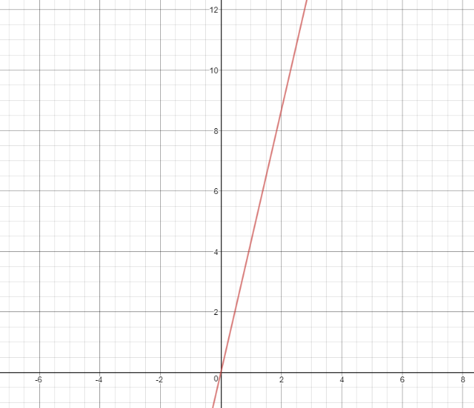

-Y-axis is I , X-axis is torque

Since Torque = R(For*g+acc) Mass

There is also aan approx. linear relation between Torque and mass , so by substituting in current torque equation ,

I=(WR(For*g+acc) /V)* MASS

The relation is showed by this graph

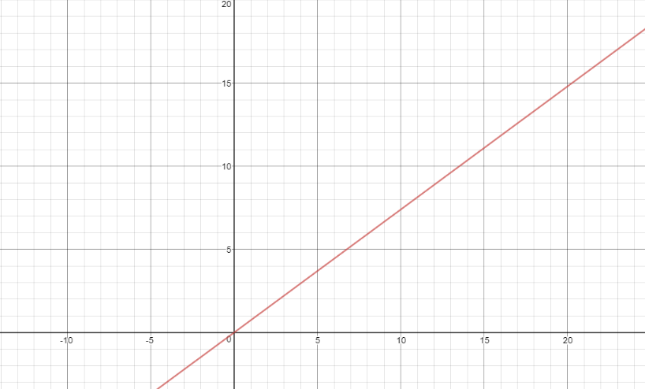

Y-axis : current

X-axis : mass

By using this graph and relation we can see if adding more batteries will give as advantage or will increase the energy used so we can compromise .

**NOTE :this graph and relations has been done manually and not revised or validated this is an approximation which could be wrong .**

References :

Graphing calculator :

<https://www.desmos.com/calculator>

Unit conversions :

-<https://www.convertunits.com/from/N-cm/to/kg-cm>

-<https://www.convertunits.com/from/RPM/to/rad/sec>

Equations :

-<https://www.physicsforums.com/threads/robot-design-torque-required.512898/>

-<http://simplemotor.com/calculations/>

- <https://www.micromo.com/technical-library/dc-motor-tutorials/motor-calculations>

- <http://www.tribology-abc.com/calculators/cycling.htm>